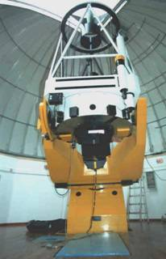

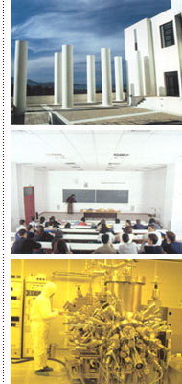



University of Crete



Department of Physics

Personnel Directory 2023-2024

Contact

The Department of Physics is located in the new campus of the University of Crete nearly 8km west-south west of Heraklion, near the University Hospital and the Foundation for Research and Technology – Hellas (FORTH). During the academic year 2023-2024 the Department consists of active 18 faculty members, 12 emeriti professors, 2 honorary professors, 20 postdoctoral researchers and long-term visitors, 41 PhD students, 30 Masters students as well as the necessary administrative and support personnel. The number of undergraduate students is nearly 1100. To contact the Department of Physics you may use the following address:

University of Crete

Department of Physics

Voutes University Campus

GR-71003 Heraklion

Greece

phone: +30 2810 394300

web: <http://www.physics.uoc.gr>

as well as one of the following phone numbers of e-mails:

|  |  |  |
| --- | --- | --- |
| ***Name*** | ***Ε-mail*** | ***Phone*** |
|  |  |  |
| ***Chair of the Department*** |  |  |
| Zezas Andreas | chair@physics.uoc.gr | 4302 |
|  |  |  |
| ***Secretary of the Chair*** |  |  |
| Pattakou Eleftheria | pattakou@physics.uoc.gr | 4300,4321 |
|  |  |  |
| ***Secretary of the Department of Physics*** |  |  |
| Kandidaki Eleni | kandida@physics.uoc.gr | 4308 |
|  |  |  |
| ***Secretariat of Graduate Studies*** | |  |
| Matalliotaki Maria | mmatal@physics.uoc.gr | 4004 |
|  |  |  |
| ***Secretariat of Undergraduate Studies*** | |  |
| Hatzinikolaki Anna | annahatz@physics.uoc.gr | 4018 |
| Tzani Eleni | tzani@physics.uoc.gr | 4003 |
|  |  |  |
| ***Secretary Institute of Computational & Theoretical Physics*** | |  |
| Kandidaki Eleni | itcp@physics.uoc.gr | 4309 |
|  |  |  |
| ***Secretary Institute of Astrophysics - FORTH*** | |  |
| Tsentelierou Eleftheria | e.tsentelierou@ia.forth.gr | 4200 |
|  |  |  |
| ***Secretary Microelectronics Group of IESL - FORTH*** | |  |
| Tzanakaki Marina | marina@physics.uoc.gr | 4105 |

1. Faculty Members of the Department & Retirees

*Personnel Directory 2023-2024*

*Last Update: October 6, 2023*

*Copyright © Department of Physics, University of Crete*

|  |  |  |  |  |  |  |  |  |
| --- | --- | --- | --- | --- | --- | --- | --- | --- |
| **Name** | | ***Ε-mail*** | | | | ***Phone*** | ***Office*** | |
| Athanasiu Grigoris | | [athanasi@physics.uoc.gr](mailto:athanasi@physics.uoc.gr) | | | | 4207 | 206 | |
| Antypas Dionysis | | [dantypas@physics.uoc.gr](mailto:dantypas@physics.uoc.gr) | | | | 4259 | 227 | |
| Apostolopoulos Vasilis | | [v.apostolopoulos@physics](mailto:v.apostolopoulos@physicsr) | | | | 4109 | 103 | |
| Charalambidis Dimitris | | [chara@iesl.forth.gr](mailto:chara@iesl.forth.gr) | | | | 1464 | FORTH | |
| Charmandaris Vassilis | | [vassilis@physics.uoc.gr](mailto:vassilis@physics.uoc.gr) | | | | 4216 | 215 | |
| Christodoulou Demetrios | | [demetri@math.ethz.ch](mailto:demetri@math.ethz.ch) | | | | 4300 | 301 | |
| Ditsas Petros | | [ditsas@physics.uoc.gr](mailto:ditsas@physics.uoc.gr) | | | | 4208 | 207 | |
| Economou Eleftherios | | [economou@admin.forth.gr](mailto:economou@admin.forth.gr) | | | | 1562 | FORTH | |
| Flytzanis Nikolaos | | [flytzani@physics.uoc.gr](mailto:flytzani@physics.uoc.gr) | | | | 4224 | 222 | |
| Fotakis Costas | | [fotakis@iesl.forth.gr](mailto:fotakis@iesl.forth.gr) | | | | 1316 | FORTH | |
| Georgakilas Alexandros | | [alexandr@physics.uoc.gr](mailto:alexandr@physics.uoc.gr) | | | | 4104 | 107 | |
| Grammatikakis George | | [grammatg@uoc.gr](mailto:grammatg@uoc.gr) | | | | 4300 | - | |
| Haldoupis Christos | | [chald@physics.uoc.gr](mailto:chald@physics.uoc.gr) | | | | 4315 | 305 | |
| Iliopoulos Eleftherios | | [iliopoul@physics.uoc.gr](mailto:iliopoul@physics.uoc.gr) | | | | 4113 | 110 | |
| Kiriakidis George | | [kiriakid@iesl.forth.gr](mailto:kiriakid@iesl.forth.gr) | | | | 1271, 1272 | FORTH | |
| Kiritsis Elias | | [kiritsis@physics.uoc.gr](mailto:kiritsis@physics.uoc.gr) | | | | 4209 | 208 | |
| Kominis Iannis | | [ikominis@physics.uoc.gr](mailto:ikominis@physics.uoc.gr) | | | | 4223 | 221 | |
| Kylafis Nick | | [kylafis@physics.uoc.gr](mailto:kylafis@physics.uoc.gr) | | | | 4215 | 214 | |
| Lambropoulos Panagiotis | | [labro@iesl.forth.gr](mailto:labro@iesl.forth.gr) | | | | 1384, 4304 | FORTH & 302 | |
| Lymperakis Liverios | | [lymperakis@physics.uoc.gr](mailto:labro@iesl.forth.gr) | | | | 4110 | 108 | |
| Makris Konstantinos | | [makris@physics.uoc.gr](mailto:makris@physics.uoc.gr) | | | | 4227 | 225 | |
| Niarchos Vasilis | | [niarchos@physics.uoc.gr](mailto:niarchos@physics.uoc.gr) | | | | 4206 | 205 | |
| Papadakis Iossif | | [jhep@physics.uoc.gr](mailto:jhep@physics.uoc.gr) | | | | 4213 | 211 | |
| Papamastorakis Ioannis | | [papamast@physics.uoc.gr](mailto:papamast@physics.uoc.gr) | | | | 4305 | 305 | |
| Papanicolaou Nikos | | [papanico@physics.uoc.gr](mailto:papanico@physics.uoc.gr) | | | | 4202 | 201 | |
| Pavlidou Vasiliki | | [pavlidou@physics.uoc.gr](mailto:pavlidou@physics.uoc.gr) | | | | 4211 | 212 | |
| Porfyriadis Achilleas | | [porfyriadis@physics.uoc.gr](mailto:pavlidou@physics.uoc.gr) | | | | 4203 | 202 | |
| Psaltakis Gregory | | [psaltaki@physics.uoc.gr](mailto:psaltaki@physics.uoc.gr) | | | | 4217 | 216 | |
| Psaltis Demetri | | [Demetri.Psaltis@epfl.ch](mailto:Demetri.Psaltis@epfl.ch) | | | | 4300 | 301 | |
| Rakitzis Peter | | [ptr@iesl.forth.gr](mailto:ptr@iesl.forth.gr) | | | | 1125 | FORTH | |
| Sotiriadis Spyros | | [ssotiriad@physics.uoc.gr](mailto:pavlidou@physics.uoc.gr) | | | | 4222 | 220 | |
| Tassis Konstantinos | | [tassis@physics.uoc.gr](mailto:tassis@physics.uoc.gr) | | | | 4219 | 217 | |
| Tsamis Nicholas | | [tsamis@physics.uoc.gr](mailto:tsamis@physics.uoc.gr) | | | | 4204 | 203 | |
| Tsironis George | | [gts@physics.uoc.gr](mailto:gts@physics.uoc.gr) | | | | 4220 | 218 | |
| Tzanetakis Panagiotis | | [tzaneta@physics.uoc.gr](mailto:tzaneta@physics.uoc.gr) | | | | 4300 | - | |
| Vardavas Ilias | | [vardavas@physics.uoc.gr](mailto:vardavas@physics.uoc.gr) | | | | 4214 | 213 | |
| Zezas Andreas | | [azezas@physics.uoc.gr](mailto:azezas@physics.uoc.gr) | | | | 4212 | 210 | |
| Zotos Xenofon | | [zotos@physics.uoc.gr](mailto:zotos@physics.uoc.gr) | | | | 4226 | 225 | |
| Zouros Theo | | [tzouros@physics.uoc.gr](mailto:tzouros@physics.uoc.gr) | | | | 4117 | 113 | |
|  | |  | | | |  |  | |
| **Department Chair:** | | chair@physics.uoc.gr | | | | 4302 | 403 | |
|  | |  | | | |  |  | |
|  | | |  | | |  |  | |
|  | | |  | | |  |  | |
| **Notes** | | |  | | |  |  | |
| Phone Preffix: +30.2810.39.xxxx | | | | | |  | | |
| The office number of each professor is indicated. To locate the offices in the building, you may consult the floor plans at the end of this document. Individuals with offices both at FORTH and in the Physics Bldg. are marked as “FORTH & XXX”. | | | | | | | | |
|  |  | | |  |  | | |  |

2. Administrative Personnel

|  |  |  |  |
| --- | --- | --- | --- |
| ***Name*** | ***Ε-mail*** | ***Phone*** | ***Office*** |
| Hatzinikolaki Anna | [annahatz@physics.uoc.gr](mailto:annahatz@physics.uoc.gr) | 4018 | 005β |
| Kandidaki Eleni | [kandida@physics.uoc.gr](mailto:kandida@physics.uoc.gr) | 4308 | 307 |
| Matalliotaki Maria | [mmatal@physics.uoc.gr](mailto:mmatal@physics.uoc.gr) | 4004 | 005β |
| Pattakou Eleftheria | [pattakou@physics.uoc.gr](mailto:pattakou@physics.uoc.gr) | 4300, 4321 | 304 |
| Tzani Eleni | tzani@physics.uoc.gr | 4003 | 005β |

3. Special Teaching and Technical Personnel

|  |  |  |  |
| --- | --- | --- | --- |
| ***Name*** | ***Ε-mail*** | ***Phone*** | ***Office*** |
| Baharidis Babis | [baharid@physics.uoc.gr](mailto:baharid@physics.uoc.gr) | 4015 | 010 |
| Karadamoglou Ioannis | [gkara@physics.uoc.gr](mailto:gkara@physics.uoc.gr) | 4163 | 111β |
| Katsidis Charalampos | [katsidis@physics.uoc.gr](mailto:katsidis@physics.uoc.gr) | 4014 | 009 |
| Paterakis George | [gpat@physics.uoc.gr](mailto:gpat@physics.uoc.gr) | 4240 | 233 |
| Psyllaki Athanasia | [apsy@physics.uoc.gr](mailto:apsy@physics.uoc.gr) | 4158 | 115β |
| Sisamakis Manolis | [msis@uoc.gr](mailto:msis@uoc.gr) | 3846 | Math Dpt. |
| Tsambos Ioannis | [johny@physics.uoc.gr](mailto:johny@physics.uoc.gr) | 4133 | 120 |

5. Computer Center Personnel

|  |  |  |  |
| --- | --- | --- | --- |
| ***Name*** | ***Ε-mail*** | ***Phone*** | ***Office*** |
| Kapetanakis Giannis | [gk@cc.uoc.gr](mailto:gk@cc.uoc.gr) | 4161 | 117β |
| Psyllaki Athanasia | [apsy@physics.uoc.gr](mailto:apsy@physics.uoc.gr) | 4158 | 115β |
| Tsambos Ioannis | [johny@physics.uoc.gr](mailto:johny@physics.uoc.gr) | 4158 | 113β |

6. Postdoctoral Researchers – Visitors – Graduate Students

Contact information for all additional personnel with offices in the Physics Bldg, including postdoctoral researchers and visitors, members of the Institute of Astrophysics and the Institutute of Electronic Structure and Laser of FORTH, as well as all graduate students can be found in the web page of the Deparment.

10. Various Rooms – Laboratories

|  |  |  |
| --- | --- | --- |
| ***Activity - Location*** | ***Phone*** | ***Room*** |
| Physics Lab Ι – Mechanics & Thermodynamics | 4023 | 012 |
| Physics Lab ΙΙ – Electricity & Magnetism | 4028 | 018 |
| Physics Lab ΙΙΙ – Optics | 4024 | 011 |
| Advanced Physics Lab I | 4026 | 013 |
|  |  |  |
| Teleconference Room (1st Floor) | 4172 | 121β |
| Conference Room (Rotunta - 2nd Floor) | 4255 | 224 |
| Seminar Room 2nd Floor | - | 238 |
| Seminar Room 3rd Floor | 4310 | 315 |
|  |  |  |
| Coffee Room 1st Floor | 4100 | 109 |
| Coffee Room 2nd Floor | 4210 | 209 |
|  |  |  |
| Skinakas Observatory Lab | 4238 | 241 |
|  |  |  |
| Visitor’s Office 2nd Floor | 4217 | 216 |
| Visitor’s Office 3rd Floor | 4303 | 301 |
|  |  |  |
| Association of Undergraduate Physics Students | 4011 | 006 |
| University of Crete Student Astronomy Group | 4022 | 004 |
|  |  |  |
| Cafeteria – Ground Foor, Physics Bldg | 4029 | - |
|  |  |  |
| Buliding Security | 4150 |  |

Floor Plans & Room numbers

Ground Floor (0) & (1/2)

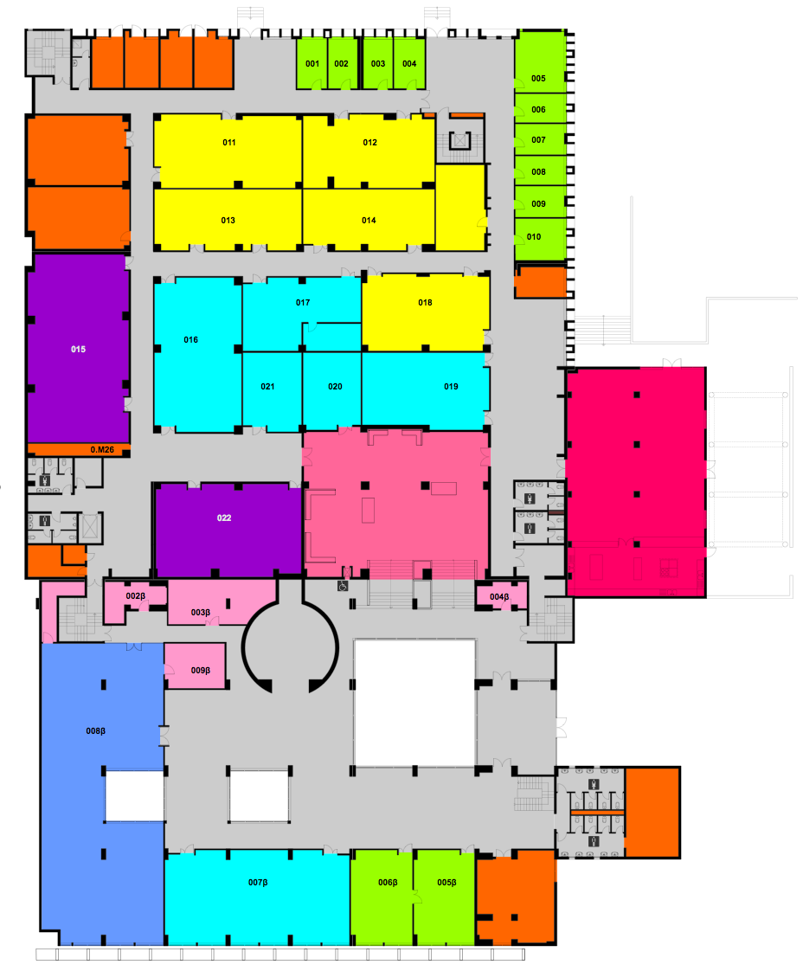

**North**

**Cafeteria**

**Physics Secretariat**

**Reading Room**

**Amphitheater Α**

**Amphitheater Β**

**Open Area Computer Room 1**

**Lecture Hall 2**

**Lecture Hall 1**

**Lecture Hall 3**

Plan of 1st Floor

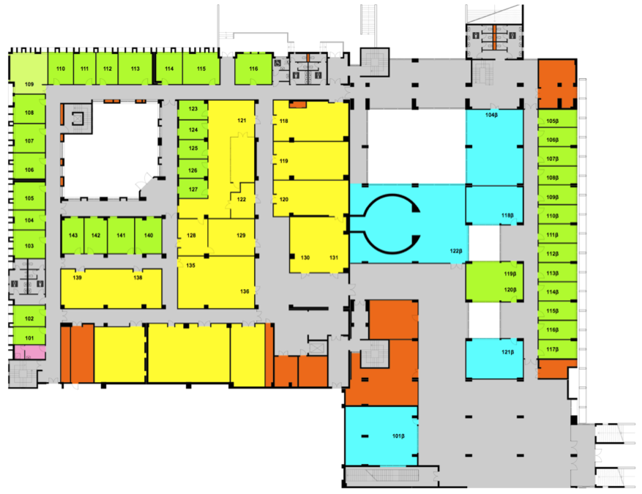

**North**

**Computer Center**

**Educational Computer Room 2**

**Teleconference Room**

**Educational Computer Room 3**

**Lecture Hall 4**

**(Fermi)**

**1st Floor Seminar Room**

Plan of 2nd Floor

**Visitor Room**

**2nd Floor**

**2nd Floor Seminar Room**

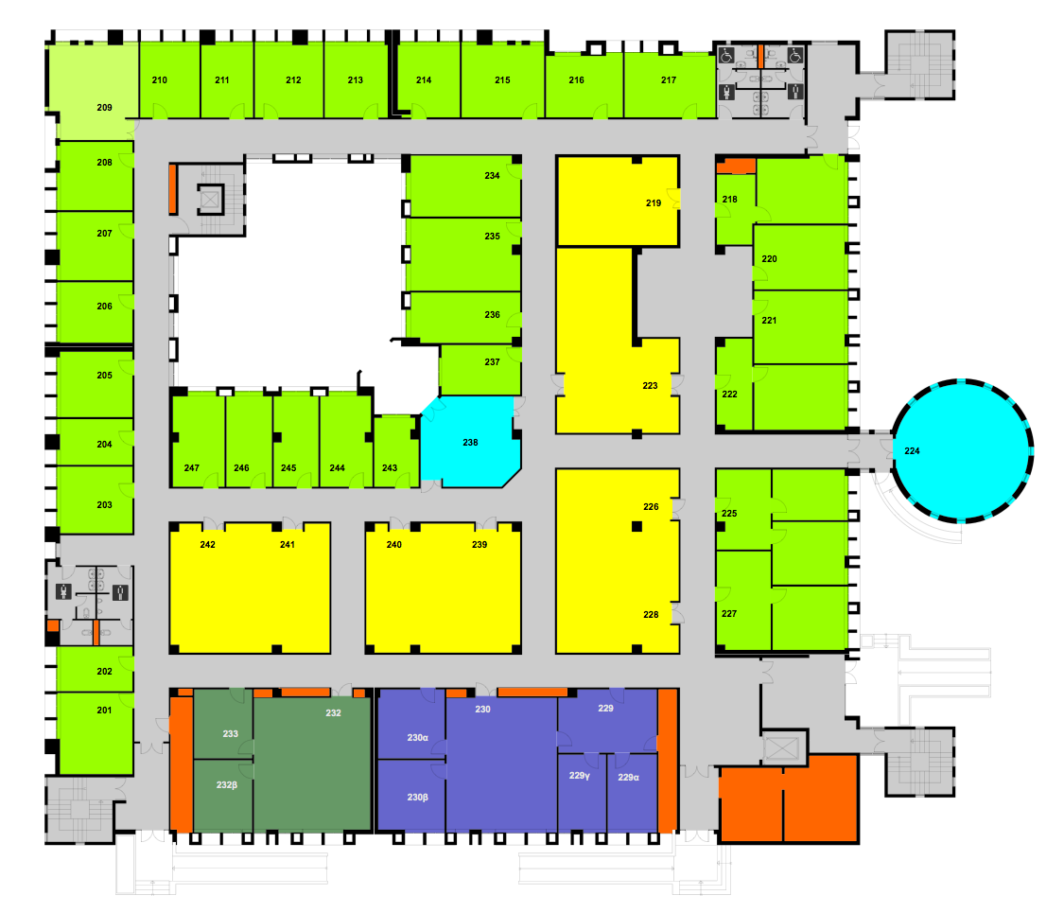

**Conference Room**

**2nd Floor (Rotunda)**

**North**

**Institute of Astrophysics - FORTH**

**Skinakas Observatory**

**Coffee Room 2nd Floor**

Plan of 3rd Floor

Untitled:Users:vassilis:Desktop:toto.png

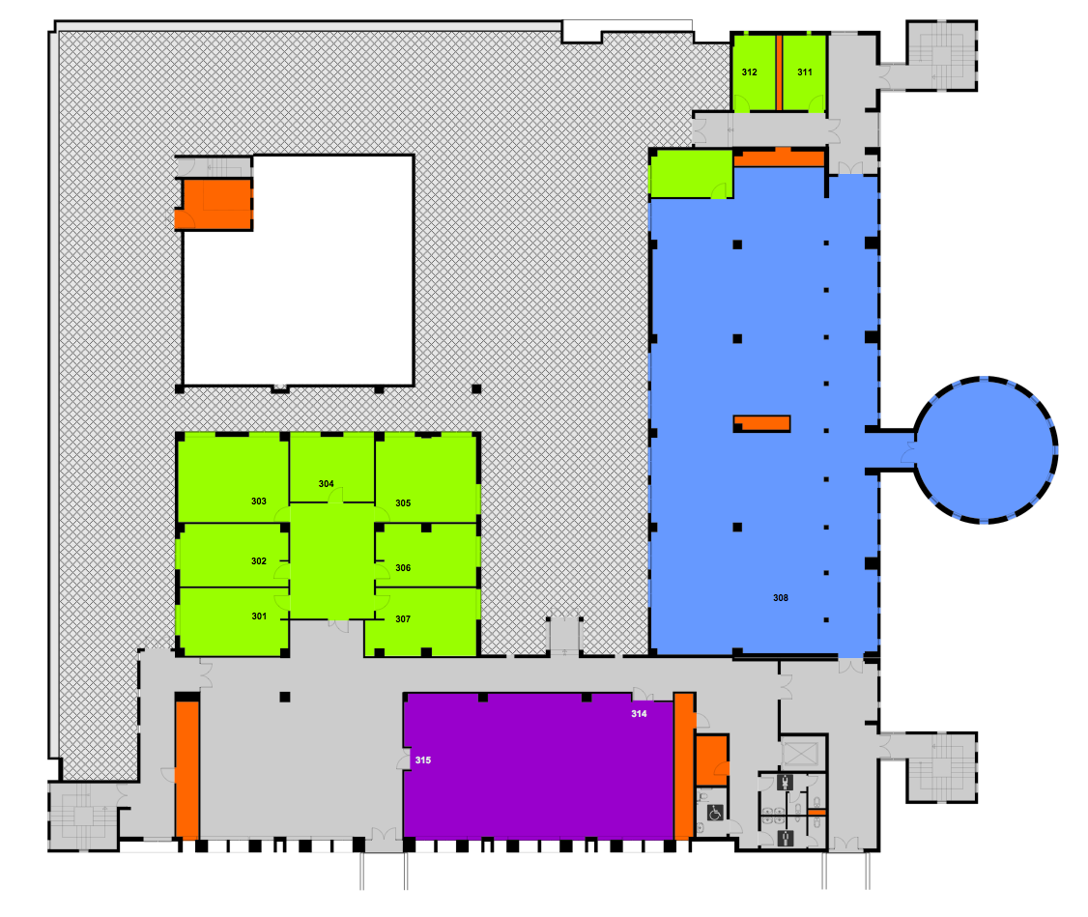

12

15

16

17

18

1

2

4

5

7

3

6

**Department Chair**

North

**Seminar Room 3rd Floor**

**(Colloquia)**

**Graduate Students and Visitors of the Department of Physics**

**Secretary of the Chair**

**Dept. of Physics**

**Secretariat**

**Visitor Room**

**3rd Floor**

9

8

10

11

20

19

14

13

**THIS PAGE**



*Personnel Directory 2023-2024*

*Last Update: October 6, 2023*

*Copyright © Department of Physics, University of Crete*